

Lab/Project Assignment Report

|  |  |  |  |  |  |  |
| --- | --- | --- | --- | --- | --- | --- |
| **Only for course Teacher** | | | | | | |
|  | | **Needs Improvement** | **Developing** | **Sufficient** | **Above Average** | **Total Mark** |
| **Allocate mark & Percentage** | | **25%** | **50%** | **75%** | **100%** | **5** |
| **Content Quality** | **2** |  |  |  |  |  |
| **Clarity** | **1** |  |  |  |  |  |
| **Spelling & Grammar** | **1** |  |  |  |  |  |
| **Organization and Formatting** | **1** |  |  |  |  |  |
| **Total obtained mark** | | | | | |  |
| **Comments** |  | | | | | |

**Semester: Spring 2023**

**Student Name: Md. Mubtasim Fuad Khan**

**Student ID:221-35-883**

**Batch: 37 Section: B**

**Course Code: SE214 Course Name: Algorithm Design and Analysis**

**Course Teacher Name: Aditi Dhali**

**Designation: Lecturer, Department of Software Engineering**

**Submission Date: 06/06/2023**

**Problem 01: Linear Search**

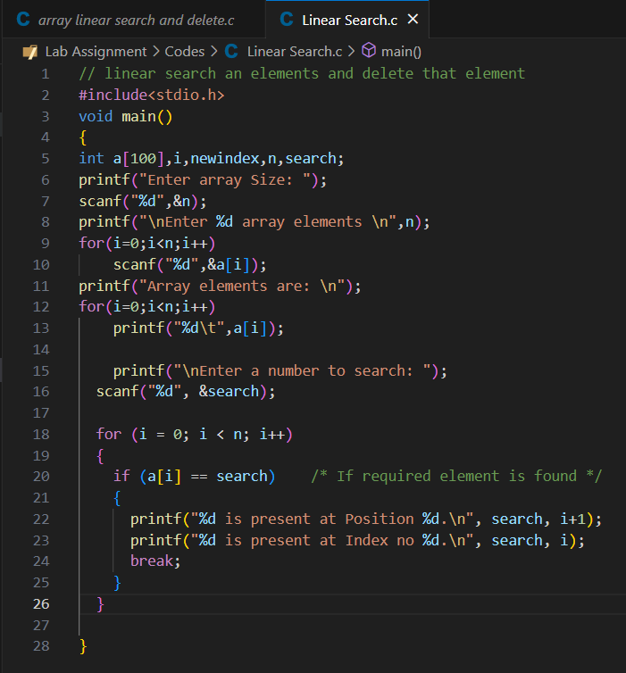

**Output:**

**Problem 02: Binary search**

**Output:**



**Problem 03: Insertion Sort**

**Output:**

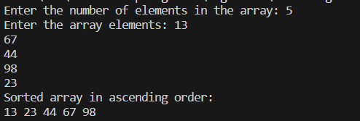

**Problem 04: Selection Sort**

**Output:**

**Problem 05: Merge Sort**

**Output:**

**Problem 06: Bubble Sort**

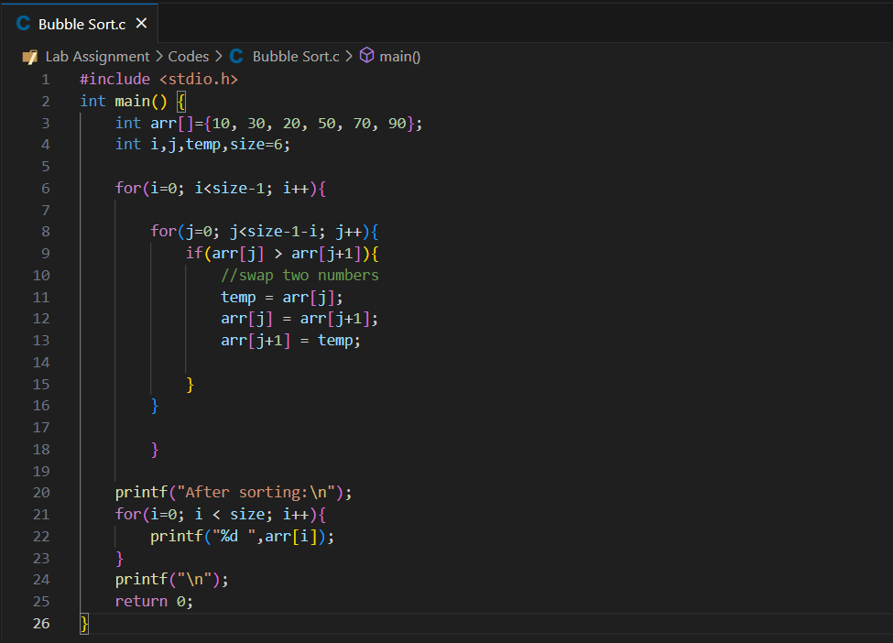

**Output:**

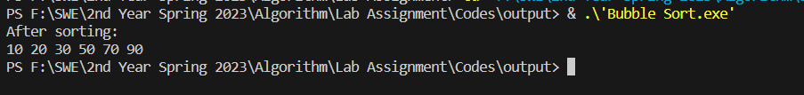

**Problem 07: Quick Sort**

**Output:**

**Problem 08: Coin change**

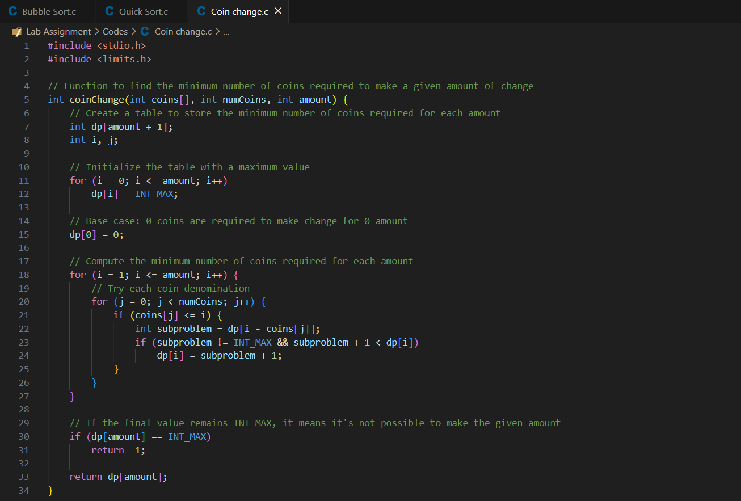

**Output:**



**Problem 09: Knap Sack**

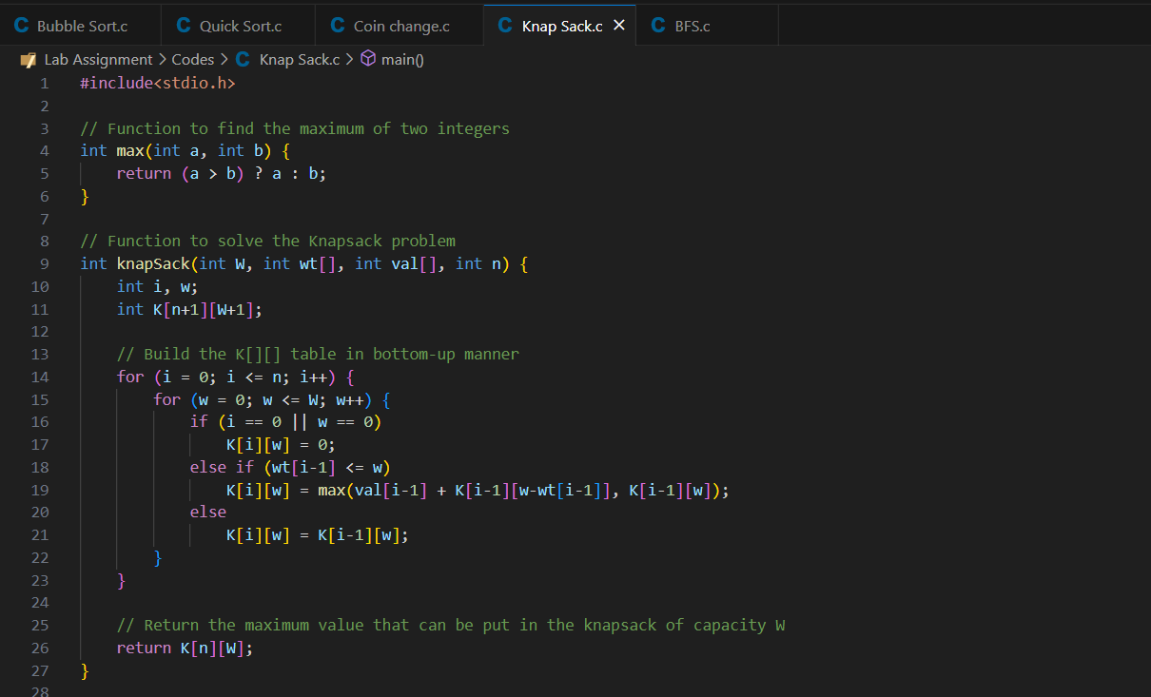

**Output:**

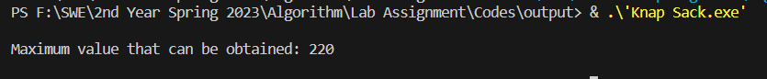

**Problem 10: BFS**

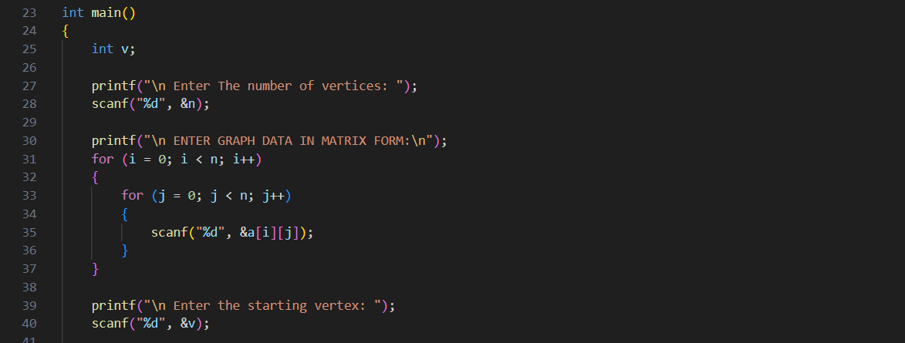

**Output:**

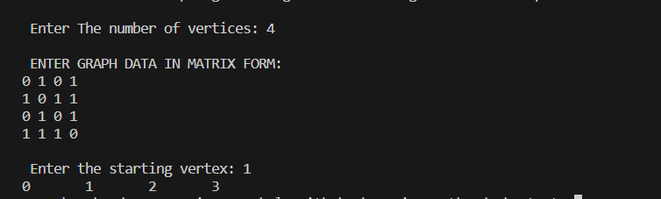

**Problem 11: DFS**

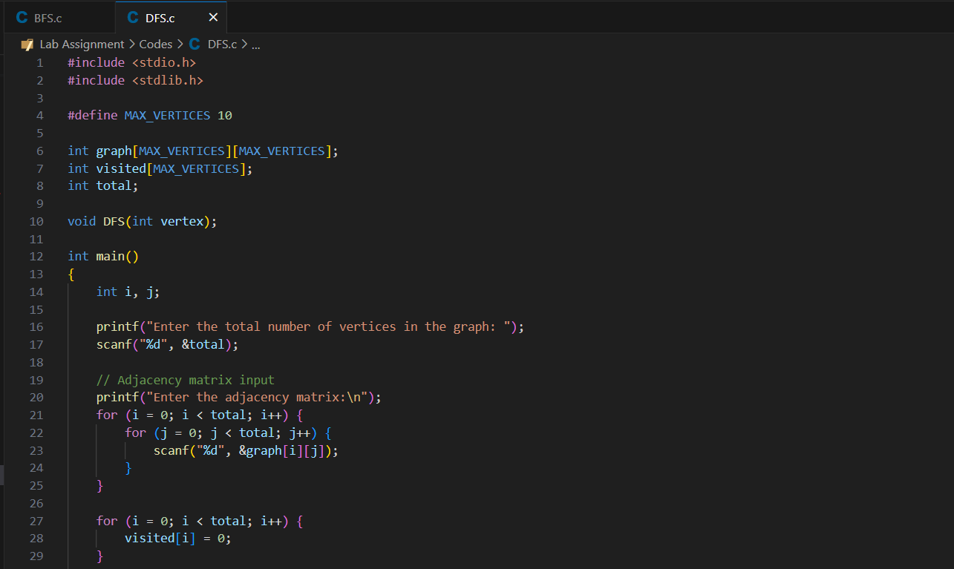

**Output:**

**Problem 12: LCS**

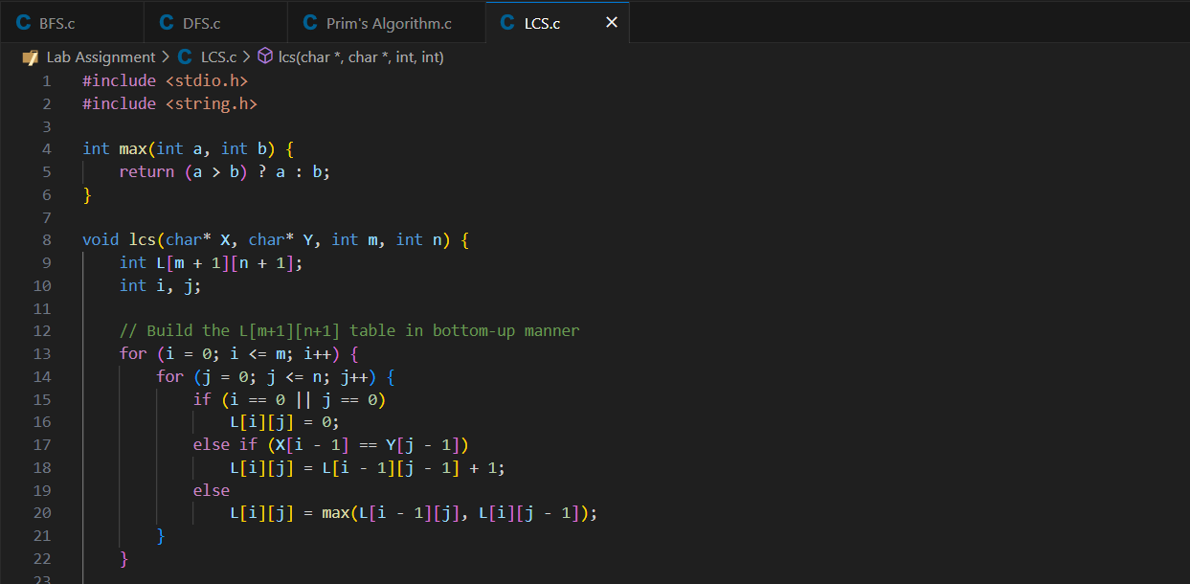

**Output:**

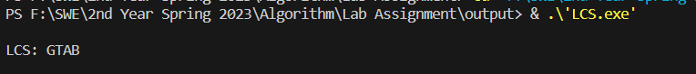

**Problem 13: LIS**

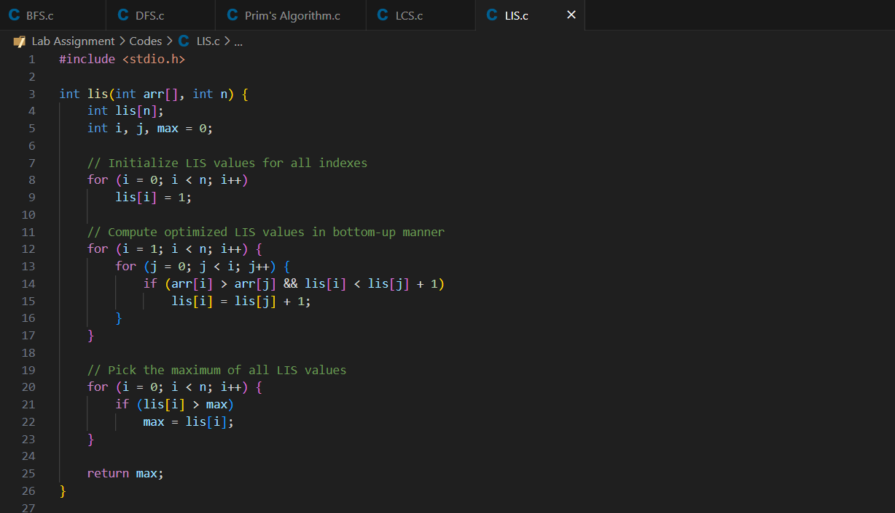

**Output:**

